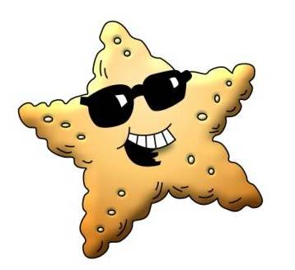
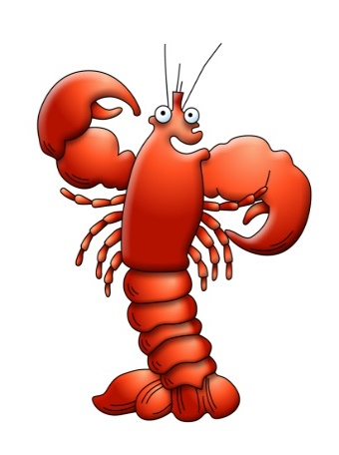
Seamor's
Underwater Challenge

- Who first invented the standard dress diving suit that our diver is wearing?

- True or false? A Cuckoo wrasse can change from being a girl (female) to being a boy (male)

- Rearrange the letters to get the name of one of the types of jellyfish found in the UK -
M O S E I N A N L

- Dead Man’s fingers are a type of British a) Soft Coral, b) Anemone, or c) Lobster?

- This is a type of animal that you could put on your salad - _ E _ C _ _ U _ B _ R

- What colour are the spots you see on young Plaice?

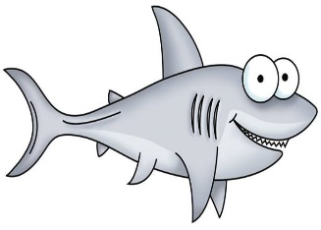
- Cuttlefish belong to the same family as Octopus and Squid? Yes or No

- What’s another name for a Lumpsucker?

- Check the board in Food Prep - who’s getting fed today?

- How many different stages are involved in the Lobster Hatchery? a) 1, b) 5, or c) 10

- True or False? It’s the female seahorse that gives birth to the babies.

- What’s the main difference you can see between the two types of British seahorse we have here at the Sea Zoo?
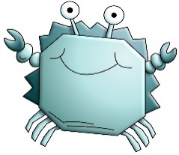
- Mermaid’s purses are the egg cases from what type of animals?

- The second largest fish in the world is the B _ _ _ _ _ _ _ _ _ _ _ !

- Does the acrylic window of the Big Fish Forest make the fish look bigger or smaller?

Thank you for taking part!
If you’d like to know if you got all of the answers right, just ask the Admissions staff.
Seamor's
Underwater Challenge

- Who first invented the standard dress diving suit that our diver is wearing?

- True or false? A Cuckoo wrasse can change from being a girl (female) to being a boy (male)

- Rearrange the letters to get the name of one of the types of jellyfish found in the UK -
M O S E I N A N L

- Dead Man’s fingers are a type of British a) Soft Coral, b) Anemone, or c) Lobster?

- This is a type of animal that you could put on your salad - _ E _ C _ _ U _ B _ R

- What colour are the spots you see on young Plaice?

- Cuttlefish belong to the same family as Octopus and Squid? Yes or No

- What’s another name for a Lumpsucker?

- Check the board in Food Prep - who’s getting fed today?

- How many different stages are involved in the Lobster Hatchery? a) 1, b) 5, or c) 10

- True or False? It’s the female seahorse that gives birth to the babies.

- What’s the main difference you can see between the two types of British seahorse we have here at the Sea Zoo?
- Mermaid’s purses are the egg cases from what type of animals?

- The second largest fish in the world is the B _ _ _ _ _ _ _ _ _ _ _ !

- Does the acrylic window of the Big Fish Forest make the fish look bigger or smaller?

Thank you for taking part!
If you’d like to know if you got all of the answers right, just ask the Admissions staff.

