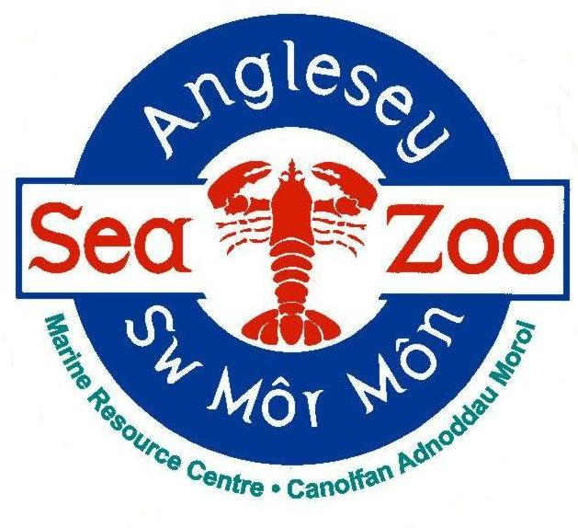
ANGLESEY SEA ZOO – General Employment Application Form

All information provided below will be kept PRIVATE AND CONFIDENTIAL.

GUIDANCE
Please read this section before returning this form.
If you require this application form in another format or have any queries when completing the form, please contact us on 01248 430411 or using the email address provided.

Please read through the following guidelines that will help you complete the application form.
- Complete all sections of the form.
- Make sure the form is tidy and try to avoid mistakes by writing out a version first to make sure you are happy with the information you are providing.
- Always read through your final version before you send it.

If you require an acknowledgement of your application:
- If emailing, you must activate a read receipt from your email account.
- If sending by post, you must enclose a stamped addressed envelope.
- Please note with limited resources, we cannot verify if we have received your application over the phone.

To complete your application:
- Please type or write clearly in black or blue ink.
- Ensure you clearly state the job title you are applying for.
- In the ‘Employment History’ section you must state why you have left a position.
- Always explain any gaps in work history.
- Proof of qualifications and membership to professional bodies may be required.

References:
- We will take up professional references once you have been interviewed and provisionally offered the post.
- Please make sure that you have given the full contact details of your referees so that this does not delay processing reference requests.
- If you have no employer references, we will take up references with named individuals at colleges where you have studied, or people who know you in a professional capacity.
- Please do not put down family members or people you live with as referees.
- You will only be confirmed in the post once we are satisfied with the information received from your referees.

The ‘Additional Information’ Section
This is the most important part of the application form.
You should consider the following:
- Applications can only be assessed on the information you provide. You need to clearly demonstrate your capabilities.
- Do not forget to present this in relation to the job description. You need to explain how you meet each of the points and provide examples from your previous experience.
- We expect your supporting statement to be a minimum of ½ of a side of A4 and a maximum of 1 sides.
- Honesty is always the best policy; please do not make false claims.
- If you are making a career change, stress what skills are transferable to the role you are applying for.
- Ensure you return your application in good time before the closing date - aim for the day before the deadline.
- Use concise, unambiguous sentences and avoid exaggerations.

Finally, good luck with your application and thank you for your interest in Anglesey Sea Zoo.

Please return this form to: Sarah Meakin (Aquarium Manager), sarah@angleseyseazoo.co.uk

DATES REQUESTED FOR WORK EXPERIENCE PLACEMENT:

PERSONAL DETAILS
Surname:
Forename(s): |  | Title:
Date of Birth if under 18 years old:
Address:  Postcode: |  | Email address:  Daytime Telephone number:  Evening Telephone number:
National Insurance Number:
Possess a current driving licence: | YES ☐ NO ☐
Access to own transport: | YES ☐ NO ☐
If you are successful in obtaining a position you will be required to provide relevant evidence of the above details prior to your appointment.

EDUCATION HISTORY
Please complete in full, with most recent first, and use a separate sheet if necessary.
INSTITUTION | START and END DATE | QUALIFICATIONS GAINED

VOLUNTEER HISTORY
Please complete in full, including any work experience, and use a separate sheet if necessary.
NAME AND ADDRESS  OF EMPLOYER | START and END DATE | JOB TITLE AND DUTIES | REASON FOR LEAVING

LEISURE
Please note here your leisure interests, sports and hobbies, other pastimes etc.

LANGUAGES
Welsh speaker? | YES ☐ NO ☐
If yes, at which level | BEGINNER ☐ INTERMEDIATE ☐ FLUENT ☐
Please state any other languages you are a fluent speaker in:

HEALTH DETAILS
Do you have a physical or mental impairment which has a substantial and long-term effect on your ability to carry out day to day activities?

Please specify any special requirements for work associated with any impairment.

Please specify any special requirements you will need to attend an interview.

ADDITIONAL INFORMATION
Please use this section to detail here your reasons for this application and to demonstrate why you think you would be suitable for the post (providing examples where possible).
Include all relevant information of knowledge, skills and experiences, whether obtained through formal employment or voluntary/leisure activities. Attach and label any additional sheets used.

REFERENCES
Please note here the names and addresses of two people from whom the company may obtain both character and professional references.
Name:  Company:  Phone number:  Email address: | Name:  Company:  Phone number:  Email address:

DECLARATION
Please read carefully and place a ‘X’ in each box to confirm each statement before signing this application.
☐ I confirm that the above information is complete and correct, and that any untrue or misleading information will give Anglesey Sea Zoo the right to terminate any position or contract offered.
☐ I agree that Anglesey Sea Zoo can create and maintain computer and paper records of my personal data. The data will be processed and stored, in accordance with the EU General Data Protection Regulation 2018, for up to two years.
☐ I understand that Anglesey Sea Zoo will not share any personal details provided with any third parties without my permission.
☐ I understand that I can withdraw my permission for the storage or sharing of my personal data at any point in time.

Signature:
Date:

If you return this form by email, you will be asked to sign your application at interview.

