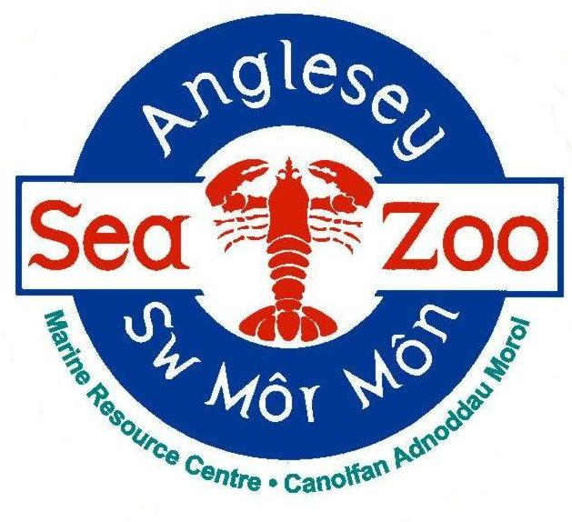**ANGLESEY SEA ZOO – General Employment Application Form**

**All information provided below will be kept PRIVATE AND CONFIDENTIAL.**

**GUIDANCE**

Please read this section ***before*** returning this form.

If you require this application form in another format or need assistance to fill in this form due to your mobility, hearing or sight, please contact us on 01248 430411 or email post@angleseyseazoo.co.uk.

Please read through the following guidelines that will help you complete the application form.

* Complete *all* sections of the form.
* Make sure the form is tidy and try to avoid mistakes.
* Always read through your final version before you send it.

**If you require an acknowledgement of your application:**

* If emailing, activate a read receipt from your email account.
* If sending by post, enclose a stamped addressed envelope.
* Please note we cannot verify if we have received your application over the phone.

**To complete your application:**

* Please type or write clearly in black or blue ink.
* Ensure you clearly state the job title you are applying for.
* In the ‘Employment History’ section you must state why you left your last job (if relevant).
* Always explain any gaps in work history.
* We will ask you to bring proof of qualifications or memberships to the interview, so you don’t have to provide them at this stage.

**References:**

* We will send for work references once you have been interviewed and provisionally offered the post. We will not contact anyone without your permission.
* Please make sure that you have given the full contact details of your referees so that this does not delay processing references.
* If you have no work references, we will accept college/University tutors or character references.
* Please do not put down family members or people you live with as referees.
* We have the right to withdraw a job offer if we are not satisfied with the information we receive on your reference or if we fail to obtain a reference within a reasonable period from when the offer was made.

**The ‘Additional Information’ Section**

This is the most important part of the application form.

You should consider the following:

* Applications can only be assessed on the information you provide. You need to demonstrate your capabilities.
* Do not forget to explain how you would be successful in the role you are applying for and use examples from your previous experience.
* Please keep your supporting statement concise and to a maximum of **500** words.
* Please do not make false claims or withhold information, or we may decide to withdraw a job offer.
* Ensure you return your application as soon as possible.

Finally, good luck with your application and thank you for your interest in Anglesey Sea Zoo.

**Position applying for:**

**Please return this form to**: [post@angleseyseazoo.co.uk](mailto:post@angleseyseazoo.co.uk)

|  |  |  |  |  |
| --- | --- | --- | --- | --- |
| **PERSONAL DETAILS** | | | | |
| Surname: | | | | |
| Forename(s): | | Title: | | |
| Date of Birth if under 18 years old: | | | | |
| Address:  Postcode: | | Email address:  Daytime Telephone number:  Evening Telephone number: | | |
| National Insurance Number: | | | | |
| Possess a current driving licence: | **YES**  **NO** | | | |
| Access to own transport: | **YES**  **NO** | | | |
| If applicable, are you willing to drive company vehicles in line with our insurance policy and company car procedures? | | | | **YES**  **NO** |
| Are you free to remain and take up employment in the UK? | | | **YES**  **NO** | |
| If not, please give further details including restrictions to the number of hours you can work *i.e.* Student Visa, 20 hours: | | | | |

***We will request proof of the above before your start date if we make you a job offer.***

|  |
| --- |
| **OTHER EMPLOYMENT** |
| Please state your availability for work (*i.e* any holidays booked, any restrictions to the number of hours you can work):  Please tell us about any other employment you would plan to continue with if you were to be successful in obtaining a position with us:  If you have two or more jobs (including this one), would you be working above **48** hours per week in total?  **YES**  **NO**  If you will be leaving your current job, please state the minimum period of notice you would need to give them: |

|  |  |
| --- | --- |
| **LANGUAGES** | |
| Welsh speaker? | **YES**  **NO** |
| If yes, at which level | BEGINNER  INTERMEDIATE  FLUENT |
| Please state any other languages you are a fluent speaker in: | |

|  |
| --- |
| **HEALTH DETAILS** |
| Do you have a physical or mental impairment which has a substantial and long-term effect on your ability to carry out day-to-day activities? **YES**  **NO**  If, yes, please give details:  Please specify any special adjustments or requirements you would need to support you in work with any health issues, disability or impairment.  Please specify any there are any special requirements you will need to attend an interview. |

|  |
| --- |
| **CRIMINAL RECORD** |
| In certain circumstances, your employment may be dependent upon obtaining a satisfactory basic disclosure from the Disclosure and Barring Service (DBS). Past criminal proceedings are not an obstacle to work unless any offences are considered relevant.  Please complete the following in line with the requirements of the Rehabilitation of Offenders Act 1974.  You are required to declare any ‘unspent’ convictions. You do not need to disclose any ‘spent’ convictions.  A criminal record will not automatically prevent your employment. We will only take into account convictions that are relevant to the role you are applying for or if your conviction poses a safety risk to you or others.  Information on this form will remain confidential and will be held on your employee file until your employment ends.  Do you have an unspent criminal conviction? **YES**  **NO**  If, yes, please give details: |

|  |  |
| --- | --- |
| Have you ever applied for any other jobs at Anglesey Sea Zoo? | **YES**  **NO** |
| If yes, please give details. | |

|  |  |
| --- | --- |
| How did you hear about this vacancy? |  |
|  | |

|  |
| --- |
| **ADDITIONAL INFORMATION** - not included in your CV |
| Please use this section to demonstrate why you think you would be suitable for the job you’re applying for (providing examples where possible).  Include all relevant information of knowledge, skills and experiences, whether obtained through formal employment or voluntary/leisure activities. Maximum of **500** words. |

|  |  |
| --- | --- |
| **REFERENCES**  Please note here the names and addresses of two people from whom the company may obtain both character and professional references. The first references must be your current or most recent employer.  We will only contact your references when you have accepted our job offer. | |
| Name:  Their job title:  Company:  Phone number:  Email address: | Name:  Their job title (or relationship with you if a character reference)  Company (if relevant):  Phone number:  Email address: |

|  |
| --- |
| **DECLARATION** |
| Please read carefully and place an ‘X’ in each box to confirm each statement before signing this application.  I confirm that the above information is complete and correct and that any deliberate omissions, untrue or misleading information will result in my job offer being withdrawn or my employment terminated if it is discovered during my employment.  I agree to undertake a Disclosure and Barring Service (DBS) for a basic disclosure if required. I understand that should the disclosure not be to Anglesey Sea Zoo’s satisfaction, any offer of employment may be withdrawn or my employment terminated.  I understand that as part of the application process, I may be asked to attend a paid work trial and only be offered a job on the successful completion of this trial.  I agree that Anglesey Sea Zoo can create and maintain computer and paper records of my personal data which will be kept for the duration of my employment. The data will be processed and stored in accordance with the General Data Protection Regulations 2018, and if my application is unsuccessful, for a maximum of three months.  I understand that Anglesey Sea Zoo will not share or sell any of my data or personal details to any third parties without my permission or unless ordered by regulatory or enforcement organisations such as the HMRC or the Police.  I understand that I can withdraw my permission for the storage or sharing of my personal data at any point in time. (Please let us know).  Signature:  Date:  If you return this form by email, you will be asked to sign your application at the interview. |