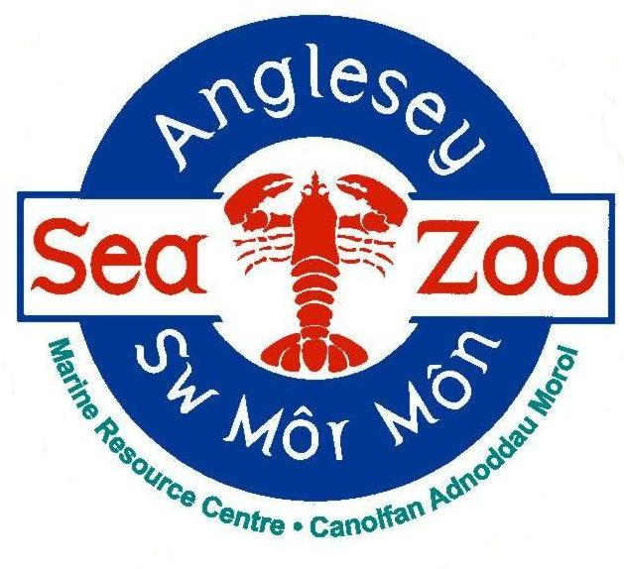
ANGLESEY SEA ZOO – Application follow up form

All information provided below will be kept PRIVATE AND CONFIDENTIAL.

GUIDANCE
Please read this section before returning this form.

If you require this application form in another format or have any queries when completing the form please contact us on 01248 430411 or using the email address provided.

Please read through the following guidelines that will help you complete the application form.
- Complete all sections of the form.
- Make sure the form is tidy and try to avoid mistakes by writing out a version first to make sure you are happy with the information you are providing.
- Always read through your final version before you send it.

If you require an acknowledgement of your application:
- If emailing, you must activate a read receipt from your email account.
- If sending by post, you must enclose a stamped addressed envelope.
- Please note with limited resources, we cannot verify if we have received your application over the phone.

To complete your application:
- Please type or write clearly in black or blue ink.
- Ensure you clearly state the job title you are applying for.
- Always explain any gaps in work history.
- Attach Proof of qualifications and membership to professional bodies.

References:
- We will take up professional references once you have been interviewed and you have authorized us to.
- Please make sure that you have given the full contact details of your referees so that this does not delay processing reference requests.
- If you have no employer references, we will take up references with named individuals at colleges where you have studied, or people who know you in a professional capacity.
- Please do not put down family members or people you live with as referees.
- You will only be confirmed in the post once we are satisfied with the information received from your referees.

The ‘Additional Information’ Section
After your CV/Cover letter, this is the most important part of the application form.
You should consider the following:
- Applications can only be assessed on the information you provide. You need to clearly demonstrate your capabilities.
- Do not forget to present this in relation to the job description. You need to explain how you meet each of the points and provide examples from your previous experience.
- Where no CV/Cover letter is provided, we expect your supporting statement to be a minimum of ½ of a side of A4 and a maximum of 1 side.
- Honesty is always the best policy; please do not make false claims.
- If you are making a career change, stress what skills are transferable to the role you are applying for.
- Ensure you return your application in good time before the closing date - aim for the day before the deadline.
- Use concise, unambiguous sentences and avoid exaggerations.

Finally, good luck with your application and thank you for your interest in Anglesey Sea Zoo.

Position applying for:

Please return this form to: Martyn Suddaby (Operations Manager), operations@angleseyseazoo.co.uk

PERSONAL DETAILS
Surname:
Forename(s): |  | Title:
Date of Birth if under 18 years old:
Address:  Postcode: |  | Email address:  Daytime Telephone number:  Evening Telephone number:
National Insurance Number:
Possess a current driving licence: | YES ☐ NO ☐
Car/motorcycle owner | YES ☐ NO ☐
Are you willing/able to drive company vehicles in line with our insurance policy and company car procedures? |  |  |  | YES ☐ NO ☐
Are you a UK citizen and free to remain and take up employment in the UK? |  |  | YES ☐ NO ☐
If no, please give further details including restrictions to the number of hours you are able to work i.e. Student Visa, 20 hours.

If you are successful in obtaining a position, you will be required to provide relevant evidence of the above details prior to your appointment.

OTHER EMPLOYMENT
Please state your availability for work (i.e. any holidays booked, any restrictions to the number of hours or days of the week you can work).

Please provide information on any other commitments / employment (paid, unpaid or voluntary) you are planning to continue with if you were to be successful in obtaining a position with us:

Please state the minimum period of final notice required for any other employment:

LANGUAGES
Welsh speaker? | YES ☐ NO ☐
If yes, at which level | BEGINNER ☐ INTERMEDIATE ☐ FLUENT ☐
Please state any other languages you are a fluent speaker in:

HEALTH DETAILS – Failure to disclose impairments that are later claimed, may result in the offer of employment being withdrawn or employment being terminated.
Do you have any physical or mental impairment(s) which may influence your ability to carry out any of the day-to-day activities of the role you are applying for?

Please specify any special requirements/work adjustments the company would need to make to help with any impairment(s).

Please specify any special requirements/work adjustments the company would need to make for you to attend an interview.

CRIMINAL RECORD
In certain circumstances employment is dependent upon obtaining a satisfactory basic disclosure from the Disclosure and Barring Service. Past criminal proceedings are not necessarily an obstacle to taking up a post. This occurs only where the offence/s is/are deemed relevant.

Please note any criminal convictions except those 'spent' under the Rehabilitation of Offenders Act 1974 (Exceptions) (Amendment) Order 1986. Any details will be discussed with you should you be the successful candidate based on your supporting statement, interview and tests. If none, please state.

Have you ever applied for any other jobs at Anglesey Sea Zoo? | YES ☐ NO ☐
If yes, please give details

How did you hear about this vacancy?

ADDITIONAL INFORMATION
Please use this section to detail any other skills, training or experience not already covered in your CV or cover letter.

REFERENCES
Please note here the names and addresses of two people from whom the company may obtain both character and professional references. Please note the professional reference must be from your previous employer in the last 12 months. References will only be taken up after you have authorised us to do so.
Name and position of referee:  Company:  Phone number:  Email address: | Name:  Company:  Phone number:  Email address:

DECLARATION
Please read carefully and place a ‘X’ in each box to confirm each statement before signing this application.
☐ I confirm that the above information is complete and correct, and that any untrue or misleading information will give Anglesey Sea Zoo the right to terminate any position or contract offered.
☐ I agree that, should I be successful in this application, Anglesey Sea Zoo may apply to the Disclosure and Barring Service for a basic disclosure, if required. I understand that should the disclosure not be to the satisfaction of the company, any offer of employment may be withdrawn or my employment terminated.
☐ I understand that as part of the application process, I will be asked to attend a series of trial days and, that only once these days are completed satisfactorily, will I be considered for a permanent position.
☐ I agree that Anglesey Sea Zoo can create and maintain computer and paper records of my personal data. The data will be processed and stored, in accordance with the EU General Data Protection Regulation 2018, for up to two years.
☐ I understand that Anglesey Sea Zoo will not share any personal details provided with any third parties without my permission.
☐ I understand that I can withdraw my permission for the storage or sharing of my personal data at any point in time.
☐ I declare that all the information contained in this application form is true and accurate and I have not deliberately withheld any information. Should it be subsequently established that I have not disclosed or inaccurately disclosed information in this application any offer of employment may be withdrawn, or my employment terminated.

Signature:
Date:
If you return this form by email, you will be asked to sign your application at interview.

